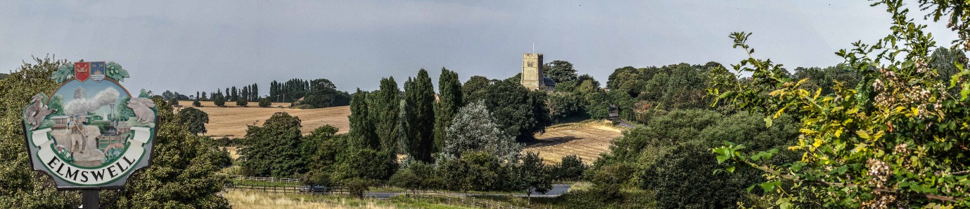

Elmswell Neighbourhood Plan
MINUTES
of a Steering Group meeting held on
23rd July 2014 at The Blackbourne
Present: Marian Abbott, Philip Blissett, Neil Brown, Julie Cole, Peter Dow, Peter Edmonds,
Terry Garner, Peter Goodridge, Sarah Mansel (Ch.), Fred Pallett, Shaun Pratt,
Ann Richards plus Gillian Benjamin of CAS.

1. Apologies for absence were received from Mary Feeney
2. The Minutes of the last meeting, held on 1st July, were approved as a true record.
3. The Meeting noted a written report as tabled to EPC on 21.07 re the MSDC Planning
Committee meeting at which the Bacon Factory Planning application was granted outline
Planning permission. Sarah Mansel confirmed the outcomes, reinforced by further
correspondence between MSDC and Messrs Bidwells as agents for Harrow Estates. Peter Dow
reinforced the key role which the NP process now plays. Both SM & PD were thanked for their
part in securing as good an outcome as could have been expected.
4. The Meeting reviewed version 3 of the draft questionnaire towards draft 4 which was to
be the basis for the first CAS software version to be put together by PD and Gillian
Benjamin for consideration at the next meeting.
5. The following were discussed and action determined:
5.1 Framework for community group visits – refer to next meeting
5.2 Protocol re email enquiries to individual Group members – defer until it happens
5.3 Historic maps for questionnaire background – PD pursuing
5.4 School Travel Plan Stats – Mary Feeney pursuing
5.5 Rail freight stats – PD pursuing
9. It was agreed that the next meeting should be scheduled for Wednesday 13th August at
Blackbourne, beginning at 7.30.
10. The meeting closed at 9.40.

Peter Dow

